2017-03-13

Bryan Greener

Chad Hirsch

Jason Gunderson

Workshop 7.82

7.82

**a)**

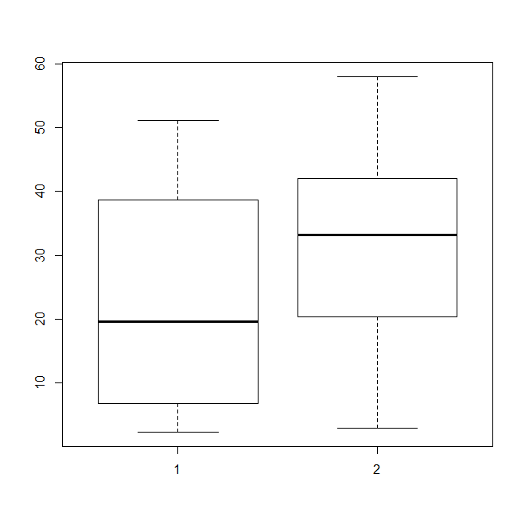

This boxplot is showing that the eastern trees (group 1) have a more narrow range of DBHs with a lower mean value and IQR however their IQR is wider than group 2. The western trees (group 2) has a wider range of DBHs and their mean and IQR have bigger diameters than group 1 however the size of the IQR is more narrow than group 1.

**b)**

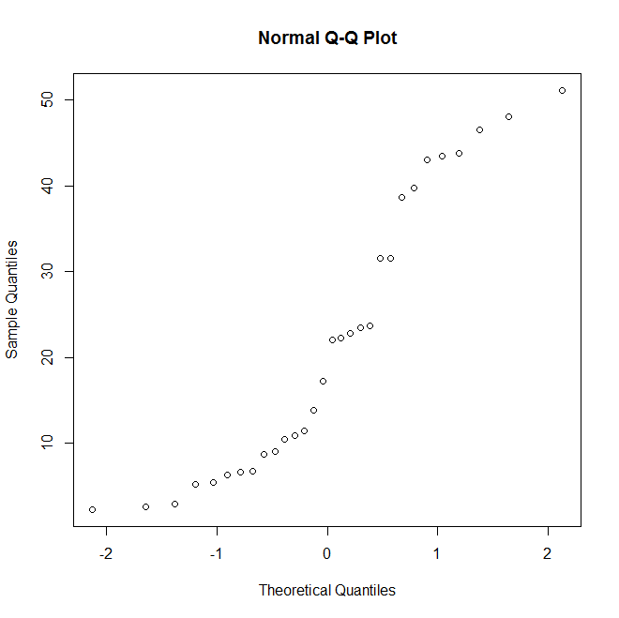

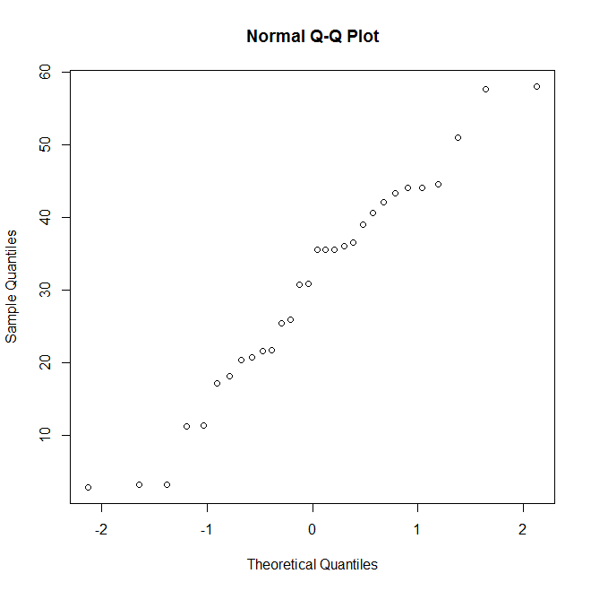

Given these two QQNorm plots, we can see that the values for group 1 (top) and group 2 (bottom) are very similar therefore we will be able to use the methods in this chapter in order to compare the two groups.

**c)**

G1 = Group 1 Mean

G2 = Group 2 Mean

H0: G1-G2=0

Ha: G1-G2 != 0

In this case, since we are just comparing the two groups of trees, our null hypothesis is that the mean difference is equal to 0. Our alternative hypothesis is that they are not equal to 0.

**d)**

data: x2 and x1

t = 2.1123, df = 57.871, p-value = 0.03899

alternative hypothesis: true difference in means is not equal to 0

Since we rejected the null hypothesis, this tells us that the difference in location of the trees is affecting the tree’s average DBH.

**e)**

95 percent confidence interval:

0.4481154 16.6852180

sample estimates:

mean of x mean of y

30.28333 21.71667

On this interval, on the 95% cases difference would fit in this range.hop

Code

data=read.csv("ewtreediameter.csv")

attach(data)

fix(data)

dbh

groupnum

# A

boxplot(dbh ~ groupnum)

# B

qqnorm(dbh[groupnum=="1"])

x11()

qqnorm(dbh[groupnum=="2"])

# C

# Find mean of group 1 and group 2

x1=dbh[groupnum=="1"]

x2=dbh[groupnum=="2"]

m1 = mean(x1)

s1 = sd(x1)

m2 = mean(x2)

s2 = sd(x2)

n1 = length(x1)

n2 = length(x2)

g1 = "East"

g2 = "West"

data.frame(g1,n1,m1,s1)

data.frame(g2,n2,m2,s2)

# D, E

t.test(x1,x2)